DAY: 1

// (overloading the * and & operator and also delete operator)

Concepts Today:
- Enum class
- Constructor Delegation
- Final
- delete , default

1. When suppose we create objects with default values we use constructor() = default.

2. Also if want to keep particular class readonly in copy construtor we use delete
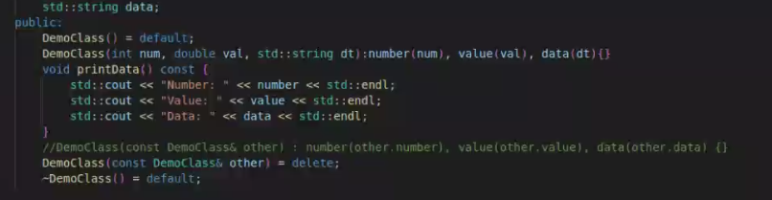

3. We can use delete in any function to restrict its access

4. If suppose we are deriving classes and we dont want to overload or override any function , we declare it as final. After that we cannot change its definition.

5. we can ue the aliases by using “using” Keyword.

6. If we dont know the datatype of variable , we can use “auto”. Copiler will guess the datatype. But possible only once. i.e. auto i = 10; (now it is int) i = 10.1 --> (not possible); also type is only built in datatypes (ex. “Ashwin” is char* array not std::string)

7. Using enum classes over enum. Explicit type casting to int when printing the value

DAY: 2
Concepts Today:
- lvalue , rvalue

1. rvalue and lvalue :- (if you can take address of expression it is lvalue. Lasts for larger duration
Rvalues are such expressions of which you cannot take address and they are temporary, dont exist after one line)

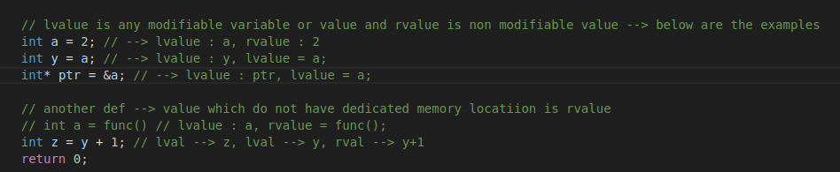

2. Using an rvalue as reference is not possible . So we use && to make rvlaue reference:
- lvalue reference --> &
- rvalue reference --> &&
(const int& p = 20) --> (exception --> if we are binding reference with const --> That’s the
reason of using const & when using copy constructor)

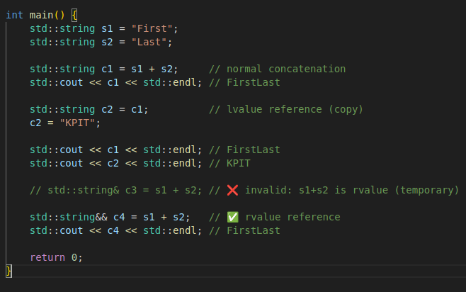

3. Why to use rvalue reference

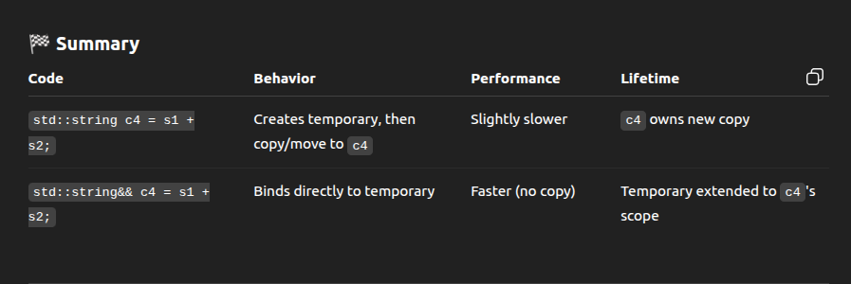

4. To convert lvalue to rvalue we use std::move() --> transfers the ownership of obj from one
location to another.
- std::move() tells compiler to consider object as temp
value
- so ownership transfer is possible
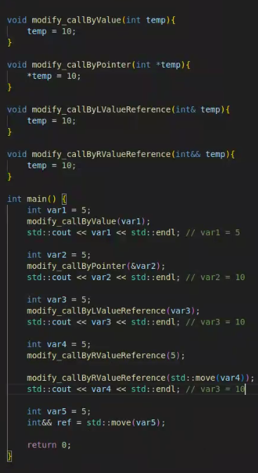
- Remember, std::move never acts like take ones value
and assign it to reference. Its just used to create reference
of r value pointing to the lvlaue;
-i.e. in the example image if we change var5 or ref both
will change.

DAY: 3
1. Move constructor

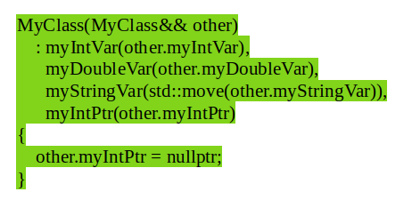

2. Initializer list:
3. Uniform initialization
- Uniform initialization preferred in main and
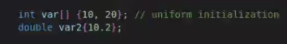
also in the class if possible.

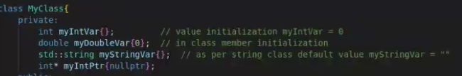

4. Lambda Functions
- Simple functions used to reduce function calliing overhaed
- act as an inline function
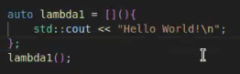
- following is the example to create
and use the la mbda functions.
- Here, [] --> capture --> to include var in scope.
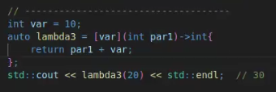
- () --> to accept arguments
- -> return type
- {} --> function body
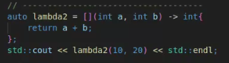

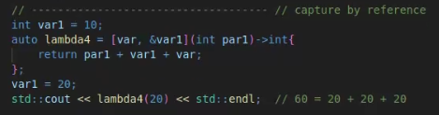
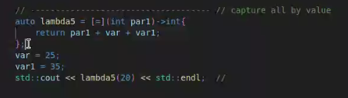

- When parameters are captured by value, the latest updated value after declaration of lambda will not be used. To use latest updated values we should use reference
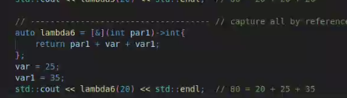
- when we want to capture all values
but only particular with ref use this
[=, &y] or vice versa [&, x]
- also when we use mutable only then can mod-
ify the scope values else not. (copy by values)
4. To maintain uniformity following kind of arrays are used
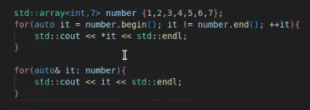

5. Printing the array elements using for each in algorithm

6. “If I store a lambda inside a std::vector or any class container, I can use variables from main() inside that lambda — but only if I capture them.
If I capture by reference ([&]), those variables must still be alive when the lambda runs.
If I capture by value ([=]), the lambda keeps its own copy and can run even after the original variables are gone.”

DAY: 4

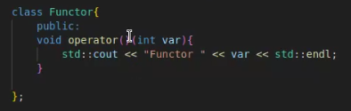
1. Functor : Is a type of class which overloads ‘()’ operator.
- any thing like functions, lambda which we can call called as callable object.

2. Function pointer :- function pointer is a pointer that stores the address of a function
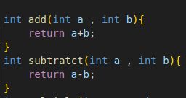
- Problem with this function pointer is that it cannot
be used with the lambdas with capture.
- Similarly we cannot convert callable object i.e. memebr function in class to a function pointer. Also can be used with static method.
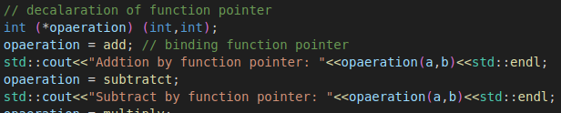
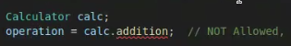

3. Writing more modular code using function pointers:
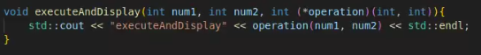
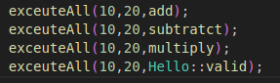

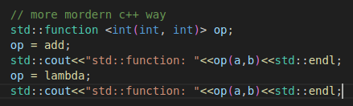
4. <functional> is a standard C++ header file that provides powerful tools for working with functions and callable objects. (solved problem for lamda with capture)

5. To use class non-static memebr function.
6. Smart Pointers:
- Instead or raw pointers use this which automatically deletes object after it gets out of scope.
- Three types:’
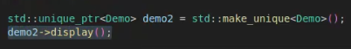
- unique_ptr
- Ownership transfer allowed . Dual reference not
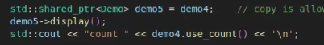
- shared_ptr
- Can be shared between more than one varaible
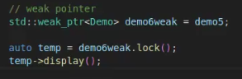
- weak_ptr
- Always work along with shared pointer.
- does not own object that it is pointing to.
- weak pointer converted to share_ptr and then used.

7. E-learning : std::array<>, std::vector<>, std::list<>, Cplusplus.com --> website to refer ,
cpp conference .com

8. in case we are using shared_ptr :- both pass by value and pass by reference allowed . Just dont us move seamantics. In other hand, if using unique_ptr then function will accept reference and use std::move() to move in vector.

9. only using emplace_back only while using unique_ptr

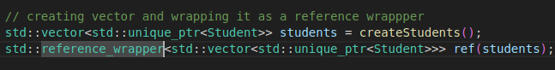
10. For wrapping the reference -->

DAY: 5

1. Threading:

- in every application there is a default thread main().
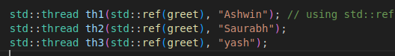
- This is how to create the new thread

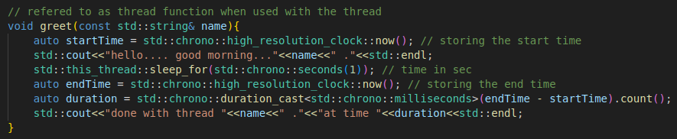
- The function which used with the thread is known as thread function.

- before exiting main we should bind the thread to the main function using .join() function.
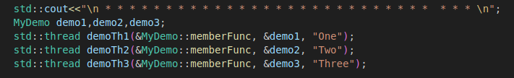
- To bind the class function to the thread use this syntax.

- Thread is also a lightweight process. Idea is to acheive parallelism by dividing process into multiplie threads. ex. Browser tabs are different threads. , ex. Spell checker in vs code

DAY: 6
1. Mutex:
- Whenever threads run, then are in race condition to excute. To synchronize the running we use mutex.
- create the object of mutex and in each function use lock, unlock to to synchronize.
- do not forget unlock else, program will get stuck.(also called as deadlock situation)
- To deal with this problem, we use std::lock_guard<std::mutex> lock(myMutex) it do not need to unlock manually.
- But disadvantage is that we cannot unlock it manually. To remove this disadvantage std::unique_lock<std::mutex> lock(myMutex) which we can unlock manually without any issue. Which was not possible by lock guard. Also there is no chance of double unlocking.
DAY: 7
- Check about how thread.detach works
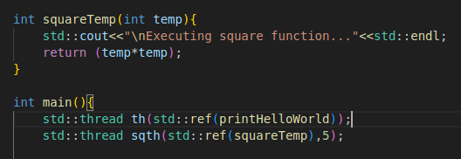

- whenever we use thread we dont have chance to receive the returned value by function.

- thread performance asynchronous operation with main. We have to use synchronous operation to receive value from the function
- to receive return value also we use async thread from <future> Library.

- std::async always return value of type std::future and to know exact value we use .get()

- instead of this std::future<int> we can also use auto for simplicity.

- async also have one initial additional attribute std::launch::async

- we dont even need to join async thread because it runs irrespective of main.

2. Promise:
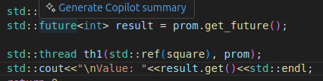
- it is some thing that the main function promise to run before its termination.

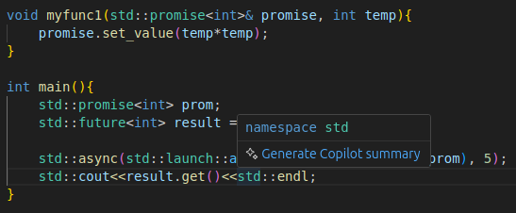
- std::promise -> represents value which is not available yet but will be available in the future.

- std::future -> represents value that will be available in future. (launching async function with promise values).

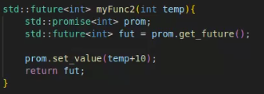
- we can also do this by creating a function -->

DAY: 8

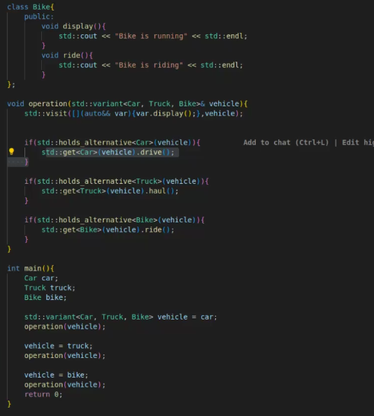
- Union --> at a time will only hold one data type

(std::optional)

- Also using union where we dont have full control that which value come is not useful
- To tackle this problem we use std::variant

- we can use lambda in particular situation so that we can work on std::variants. And we use std::visit to accurately write that lambda so that we can easily work on them. But remember that std::visit only can be used with the std::variant

- also using any value in std::variant we have to use std::get<type>(variable_name) to get that value first and then we can perform applications as per our need.

Day 10

1. Fold expressions are kind of things whihc are used when we want to make our any function dynamic such that it will accept any no of and any type of arguments easily.

2. whenever writing this template things for class, keep there entire declaration and definition inside the .h file only. Else it will give the linker error.
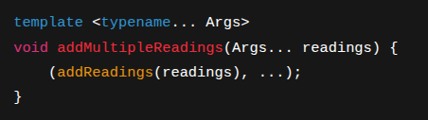
3. whenever using it for calling and funtion which can accept only one arg at a time do it like this (if function accepts one val at a time then only use this). If the other function is accepting the multiple values at a time the use this (addReadings(readings...))

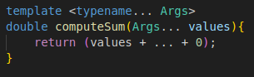
4. whenever using it as a normal global function use it like this

5. There is difference between ::::: std::numeric_limits<double>::lowest() --> actual min val
and std::numeric_limits<double>::min() --> 0.000000000023 something
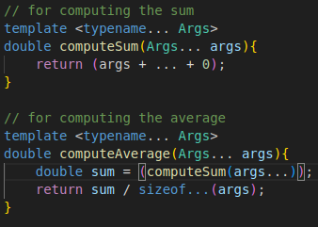
6. to calculate how much elements we are using within the fold expressions we use

7. There is a special attribute sizeof...(args) which can tell how much values are we really accepting.

Day 11

1. std::unordered_map<> --> stores data in random order

2. std::map<> ---> stores data in sorted order

3. std::stack<> --> to store elements in LIFO order (methods are push, pop , empty, top, )

4. std::queue<> --> to store elements in FIFO order( similar methods , front(), back())

5. std::priority_queue<> --> stores elements in queue in priority order

Day 13

1. To use algorithms use <algorithm> library
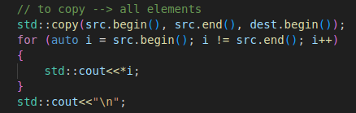
- Copy all elements

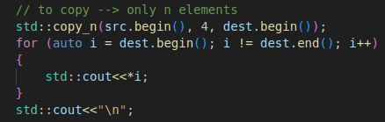
- Copy ‘n’ elements

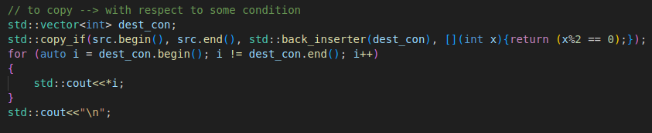
- Copy w.r.t some condition
(using std::back_inserter if vector is empty
as at start vector.begin() and end() are same)

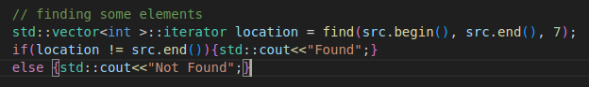
- Finding some elements

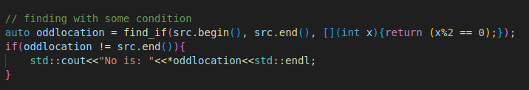
- find with some condition

2. Rule of 3 , 0 , 5:
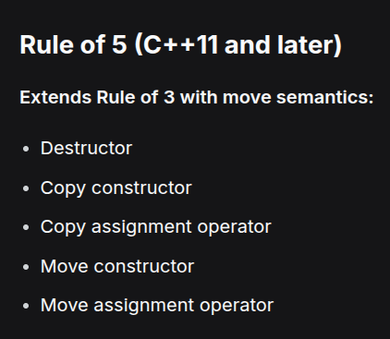

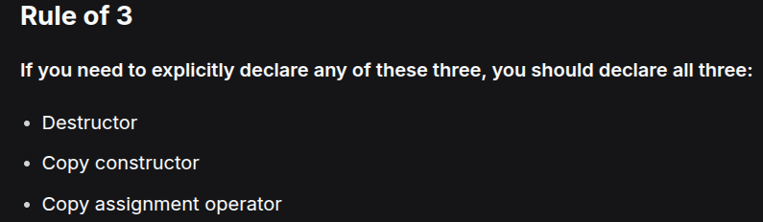
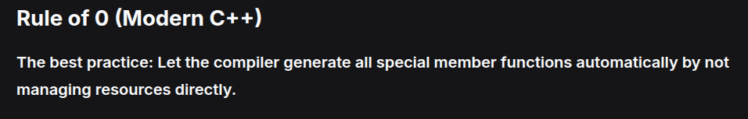

2. All the imp to keep in mind

- To copy with condition --> std::copy_if , std::copy_if , std::copy
- For filtering based on true or false --> std::any_of , std::all_of, std::none_of
- To count --> std::count_if
- To Find Based on some condition: --> std::find_if
- For iteration of inplace and by value --> std::next, std::advance
- For each obj --> std::for_each(start , end, lambda(with condition if necessary))
- function to calculate values like sum --> std::accumulate(start, end, initialValue, optional_operation);
- function to convert the container objs into parameter packs -->
--> in for_each if using in class, we cannot capture class members. Instead capture this and then use as per want

--> for all objects which are going to return something like bool in case of std::any_of etc. Dont forgot to use the return statement

3. Cmake:- "When working with multiple source files, modifying just one file (like

"When working with multiple source files, modifying just one file (like main.cpp) shouldn't require recompiling all files. Build systems like CMake generate build configurations that support incremental compilation, compiling only the changed files and their dependencies, significantly reducing build times."
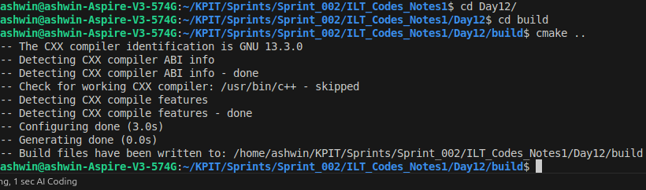

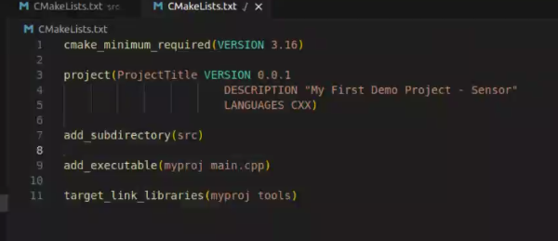
- This is how to compile and then it creates all builds in build folder. Now everytime just compile using the ‘make’ command.

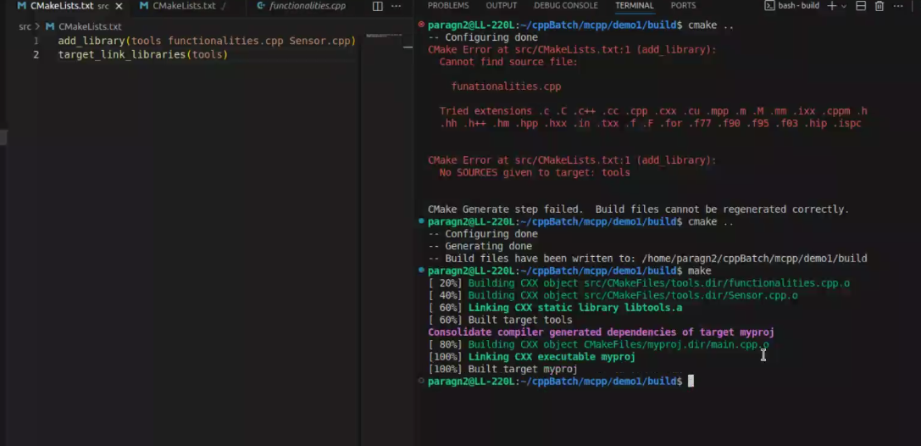

Difficult --> and practice them 100% later

1. MD14 --> task 4

2.

